BASH CHALLENGES
1. a.) Display the path of your current directory
pwd
command is used to display the path of current directory

( b.) List out the contents of your current directory
ls
command is used to list out contents of current directory

( c.) List out the contents of your current directory including hidden files
ls –a
command is used to list out contents of current directory including hidden files

2.
( a.) Create a new directory named a
mkdir a
(make directory) command is used to make create a new directory .mkdir a creates new directory with name a
( b.) Move to the newly created directory a
cd a
(change directory) command is used to change the current working directory . cd a traverses to directory a.

( c.) Create a blank file named “file1”
touch file1
touch command is used to create a file without any content .

( d.) Display the file type of “file1”
file file1
file command is used to determine the type of a file and its data
( e.) Add the line “Hello World” to “file1” using the command echo
echo “Hello World” >>file1
echo command can be used to add new text file to a file or overwrite the previous texts in a file.
( f.) Display the contents of “file1”
cat file1
cat command is used to display the content of a file. It can also be used to add content to an existing file.

( g.) Display the file type of “file1” again
file file1

3. ( a.) Stay in directory a. Create a file “file2” and add the contents below using the command cat
touch file2
cat <<EOF > file2
First Line Second Line Third Line
EOF
Touch command is used to create file 2 and cat command was used to add content to file 2.EOF stands for End Of a File. Contents can be added in the space between <<EOF and EOF.

( b.) Display the contents of “file2”
cat file2

( c.) Display the contents of “file2” with the lines reversed
tac file 2
can be used to reverse the lines
rev file 2

can be used to reverse the characteristics within a single line.

4.
a.) Stay in directory a. Concatenate the contents of “file1” and “file2” and save them into a new file “file3”
cat file1 file 2 > file3
contents of two files can be concatenate the contents into file3.if file 3 doesn’t exist it will be created or if already contents are there, it will be overwritten.

( b.) Display the contents of “file3”
file file3

b. cat file3

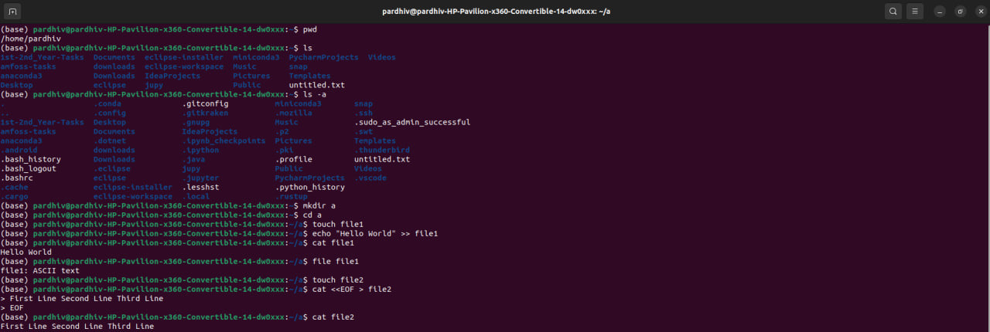

5.( a.) Stay in directory a. Create 2 directories b/c with a single command
( b.) Create a new directory d

( c.) Copy the directory d to directory c using a single command

( d.) Delete the directory d in the current directory a

( e.) Copy “file3” to the directory d with a single command

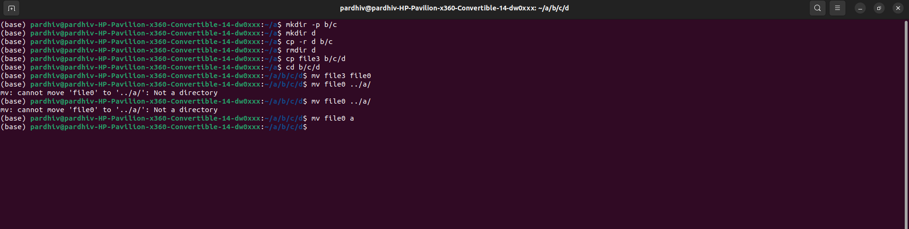

6.
a.) Go to directory d and rename “file3” to “file0”

( b.) Stay in the same directory and move “file0” to directory a

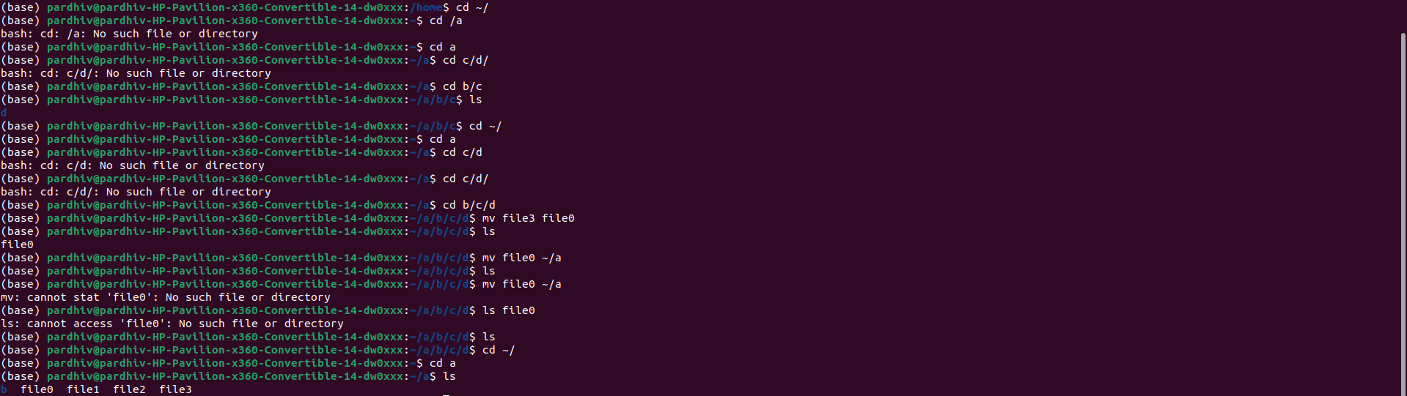

7.
a.) Go to your home directory
b.) Create a file named “test” in the directory a/b/c/d
c.) Stay in the home directory. Find and display the path of “test”

8.)( a.) Go to directory a. Get the man page of grep and save its contents to a file named “grepman.txt”

( b.) Print the lines containing the word “FILE” (Case sensitive) in the file “grepman.txt”

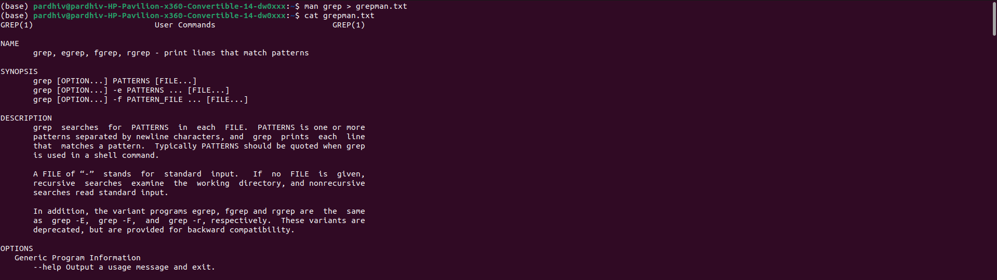
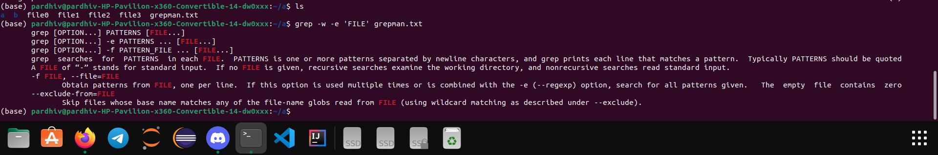

9.( a.) Go to directory a and remove the directory b with a single command

( b.) Remove the files starting with the word “file” with a single command.

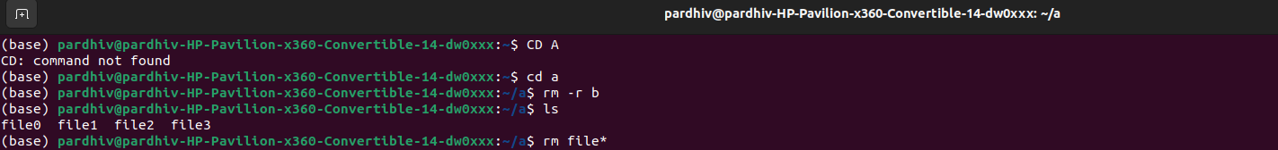

10.)
a.) Go to https://blog.bi0s.in/ and download the logo.png image using wget
b.) Do the same with python script (Hint : request library)
(c.) Also, display the metadata of the png.

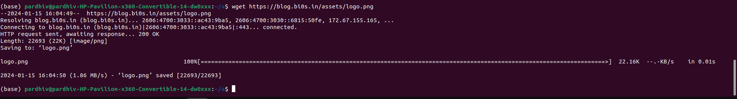

import requests
from PIL import Image

url = 'https://blog.bi0s.in/assets/logo.png'

response = requests.get(url)

if response.status_code == 200:

with open('img.png', 'wb') as file:
file.write(response.content)

img = Image.open('img.png')
img.show()
print("Image downloaded and displayed successfully.")
else:
print(f"Failed to download image. Status code: {response.status_code}")

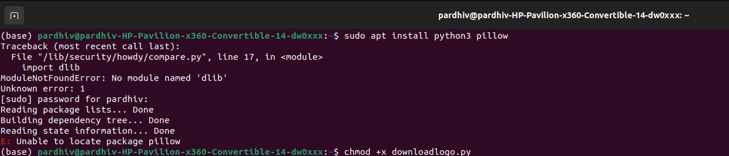

11. a.) Use traceroute on google.com and find list of the IP addresses and hostnames between you and google.com
( b.) Find Subdomains,ip addresses of google.com using nslookup command
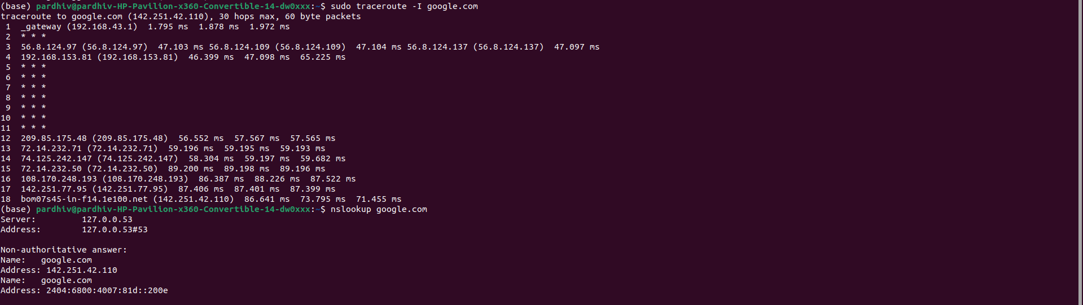
12.
Start a web server on port 8080 with python command
(In any directory and access the files in web browser )

13.
( a.) Learn about nmap and use that scanner to scan your own machine
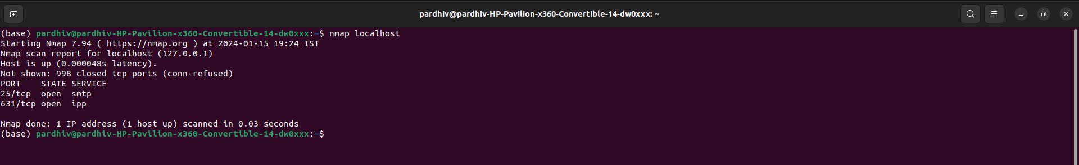

(b.)

Go to https://tryhackme.com/room/furthernmap and get ip address and Scan the ip address with (-sS,-sV,-A) in your terminal include all ports

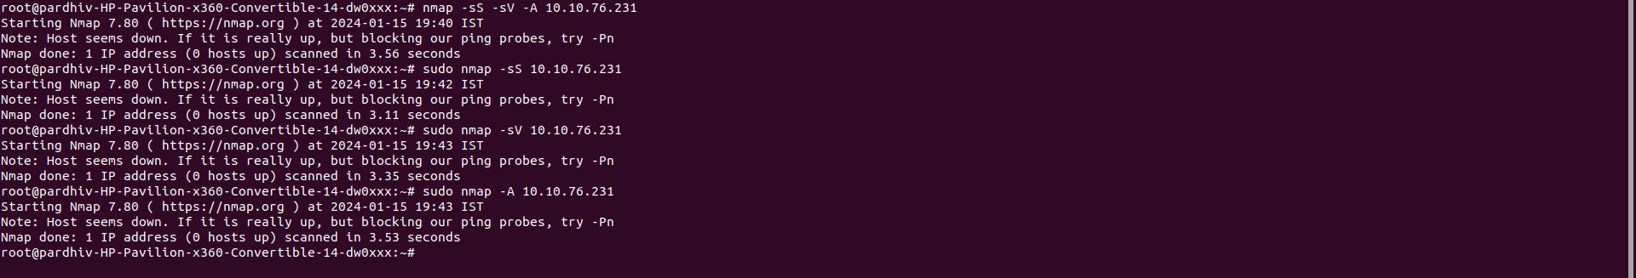

14.

( a.) Create a chat application using nc on your local machine with one terminal as server and other as the client

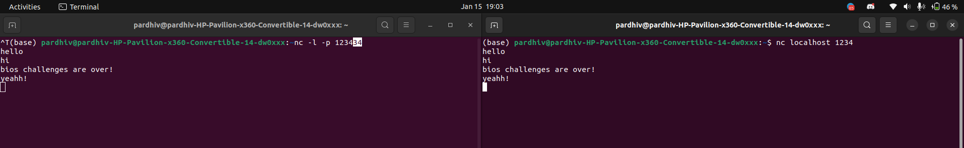
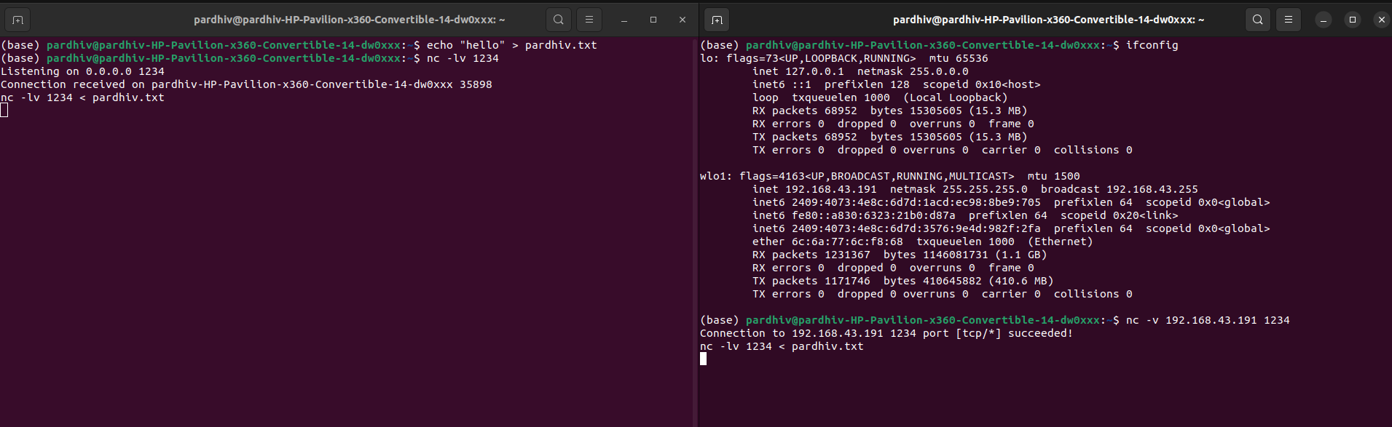
( b.) Transfer a file from server to client (save that file with another name) and display the file.

